Name:

ID:

M2 Exam

Part: A

1. What is the output of the following?

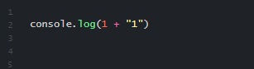

|  |  |
| --- | --- |
| 2 | 11 |
| console.log(1+”1”) | 1+”1’ |
| 111 | 111 |
| 1 | 0 |

1. What is the value **name.length**?

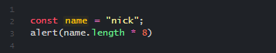

|  |  |
| --- | --- |
| 32 | 64 |
| 1 | 8 |
| 4 | 10 |
| 6 | 0 |

1. Consider the following:

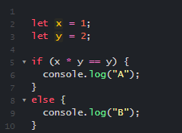

* What values of x and y could generate A as output?

|  |  |
| --- | --- |
| x = 2, y = 2 | x = 3, y = 3 |
| x=100, y=200 | x=13, y=22 |
| x=-12, y = -33 | x = 1.1, y = 1.5 |
| x = “1”, y = “2” | x = 1, y = 17 |

1. Consider the following:

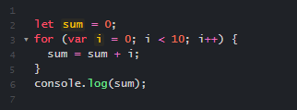

* How can the code be changed to get the sum of the integers between 32 and 64?

|  |  |
| --- | --- |
| (var i = 0; i < 32; i ++) | (var i = 31; i < 35; i ++) |
| (var i = 0; i < 64; i ++) | (var i = 32; i < 65; i ++) |
| (var i = 0; i < 65; i ++) | (var i = 32; i < 64; i ++) |
| (var i = 0; i < 31; i ++) | (var i = 32; i < 10; i ++) |

1. What is the output of the following?

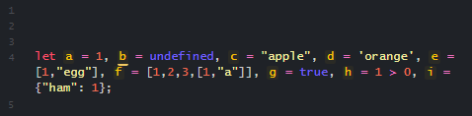

* What is the data type of h?

|  |  |
| --- | --- |
| integer | float |
| number | variable |
| string | boolean |
| list | h |

1. Who founded the internet?

|  |  |
| --- | --- |
| Larry page | Mark Zuckerberg |
| Albert Einstein | Alan Turing |
| Tim Lee | Tim Allen |
| Alan page | Charles babbage |

1. What is the base 10 number 17 in binary?

|  |  |
| --- | --- |
| 111 | 10001 |
| 1001 | 010 |
| 1010 | 1000 |
| 110011 | 1110 |

Part 2)

1. Create the following table in HTML, paste your code below:

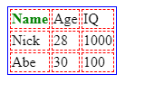

1. Create an HTML page that has an ordered list of 3 things that you like. Each list item should have a hyperlink (<a> </a>) to a website about that interest:

